**CST-235 Java Application Programming Project Status and Design Report**

|  |  |  |
| --- | --- | --- |
| **Topic:** | *Topic 4: Business Layer in Java EE* | |
| **Date:** | *11/8/2020* | |
| **Revision:** | *Version 4.0* | |
| **Team:** | 1. *Micah Miller* | |
| 1. Vrijesh Patel | |
| 1. Austin Driver | |
|  | |
| **Weekly Team Status Summary:** | |  |  |  |  | | --- | --- | --- | --- | | **User Story** | **Team**  **Member** | **Hours**  **Worked** | **Hours Remaining** | | *Micah worked on updated all three documentation files including the Project Report. Micah also, commented the code of new files that were created in this milestone. Updated some diagrams in the Project Report including the sitemap.* | *Micah Miller* | *3* | *0* | | *Vrijesh created the productDisplay.java to display a data grid of products. Vrijesh also, updated some of the WebContent XHTML files.* | *Vrijesh Patel* | *3* | *0* | | *Austin helped to create the product and products classes.* | *Austin Driver* | *3* | *0* | | |
| **GIT URL:** | [*https://github.com/AuziMan/CST-235-Project*](https://github.com/AuziMan/CST-235-Project) | |
| **Peer Review:** | *Y* | We acknowledge that our team has reviewed this Report and we agree to the approach we are all taking. |

**Planning Documentation**

**Agile Scrum Product Backlog:**

*Have not gone over what an Agile Scrum Backlog is in class.*

**Agile Scrum Sprint Backlog:**

*Have not gone over what an Agile Scrum Sprint Backlog is in class.*

**Agile Scrum Burn Down Chart:**

*Have not gone over what an Agile Scrum Burn Down Chart is in class.*

**Agile Retrospective Results:**

*Have not gone over what Agile Retrospective Results are in class.*

|  |
| --- |
| **What Went Well** |
|  |
|  |
|  |

*The following table should be completed after each Retrospective on Things That Didn’t Go Well (Stop Doing) and What Would Be Done Differently Next Time with an Action Plan to Improve (Try Doing and Continuous Improvement). An alternative to the following table is to use a mind mapping tool such as Coggle; if you use a mind mapping tool, you must include the URL or image file.*

|  |  |  |
| --- | --- | --- |
| **What Did Not Go Well** | **Action Plan** | **Due Date** |
| Unsure how to implement a database without using MySQL Database | Message the teacher on Slack how we are supposed to be implementing the databases. | s |
|  |  |  |
|  |  |  |

**Design Documentation**

**Install Instructions:**

*Not sure what is supposed to be under this section of the design documentation.*

**General Technical Approach:**

*We decided to build a computer store e-commerce application. Each product will contain year built, model name, features, color, Size of Ram, processor type, hard drive, display type, operating system, and graphic card. We will have page for listing all product, add new product, delete product and search for a product.*

**Key Technical Design Decisions:**

*We will be using Java EE MVC patterns. We will have login page, welcome page, register page, product catalog, shopping cart page. We will also add admin sites like add a new product or edit a page. We chose this design because it is easier to navigate through the application and make changes where they may be needed.*

**Known Issues:**

*We do not have any known issues at this current time.*

**Risks:**

*User logging in with wrong credentials and gaining access. Losing data by not having a database in place. Making sure to use a good practical n-layer design architecture with a focus on security.*

**ER Diagram:**

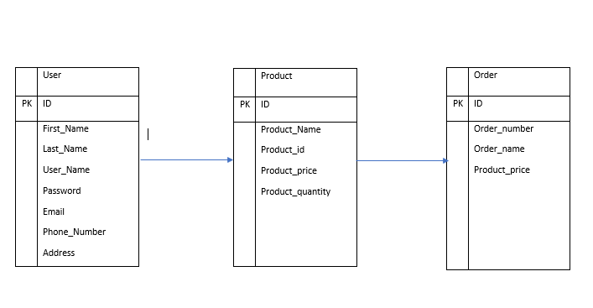

**DDL Scripts (Rough draft):**

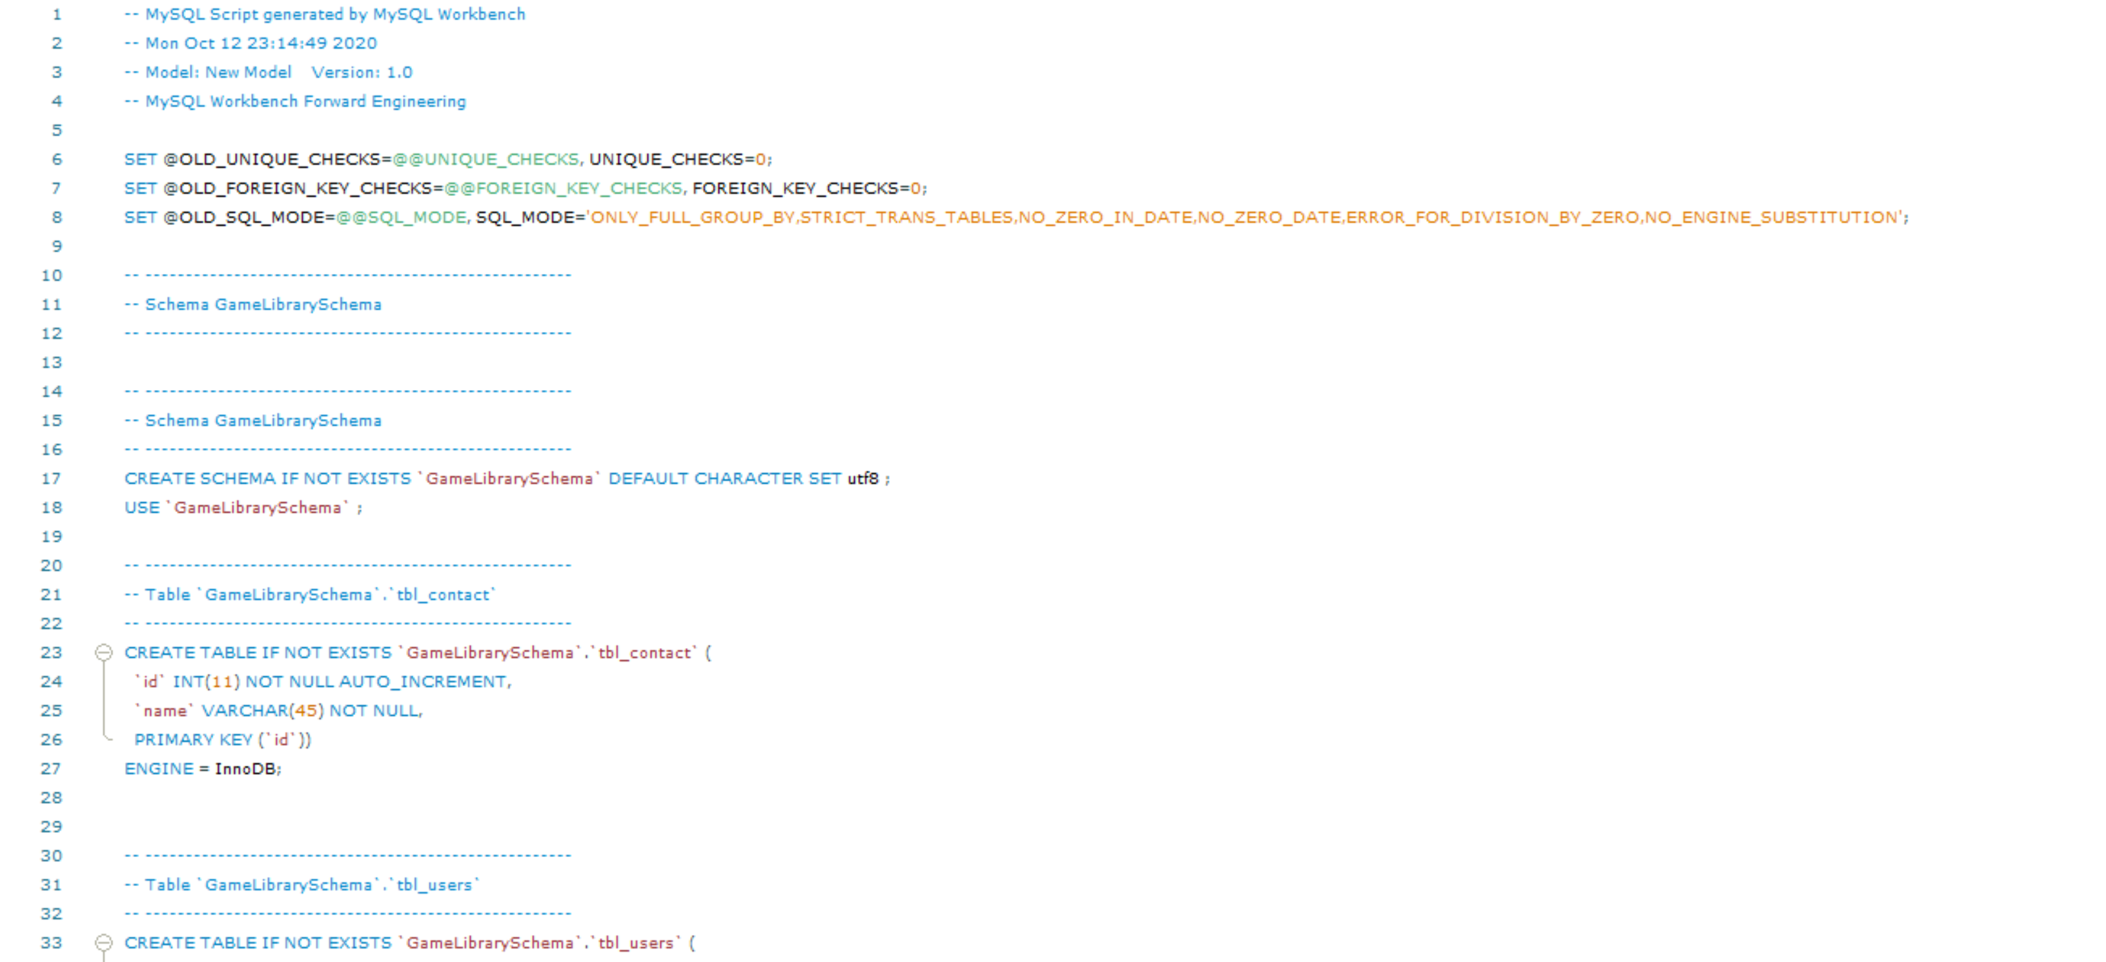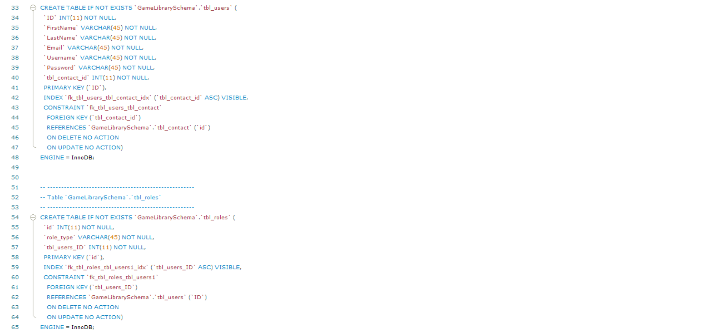

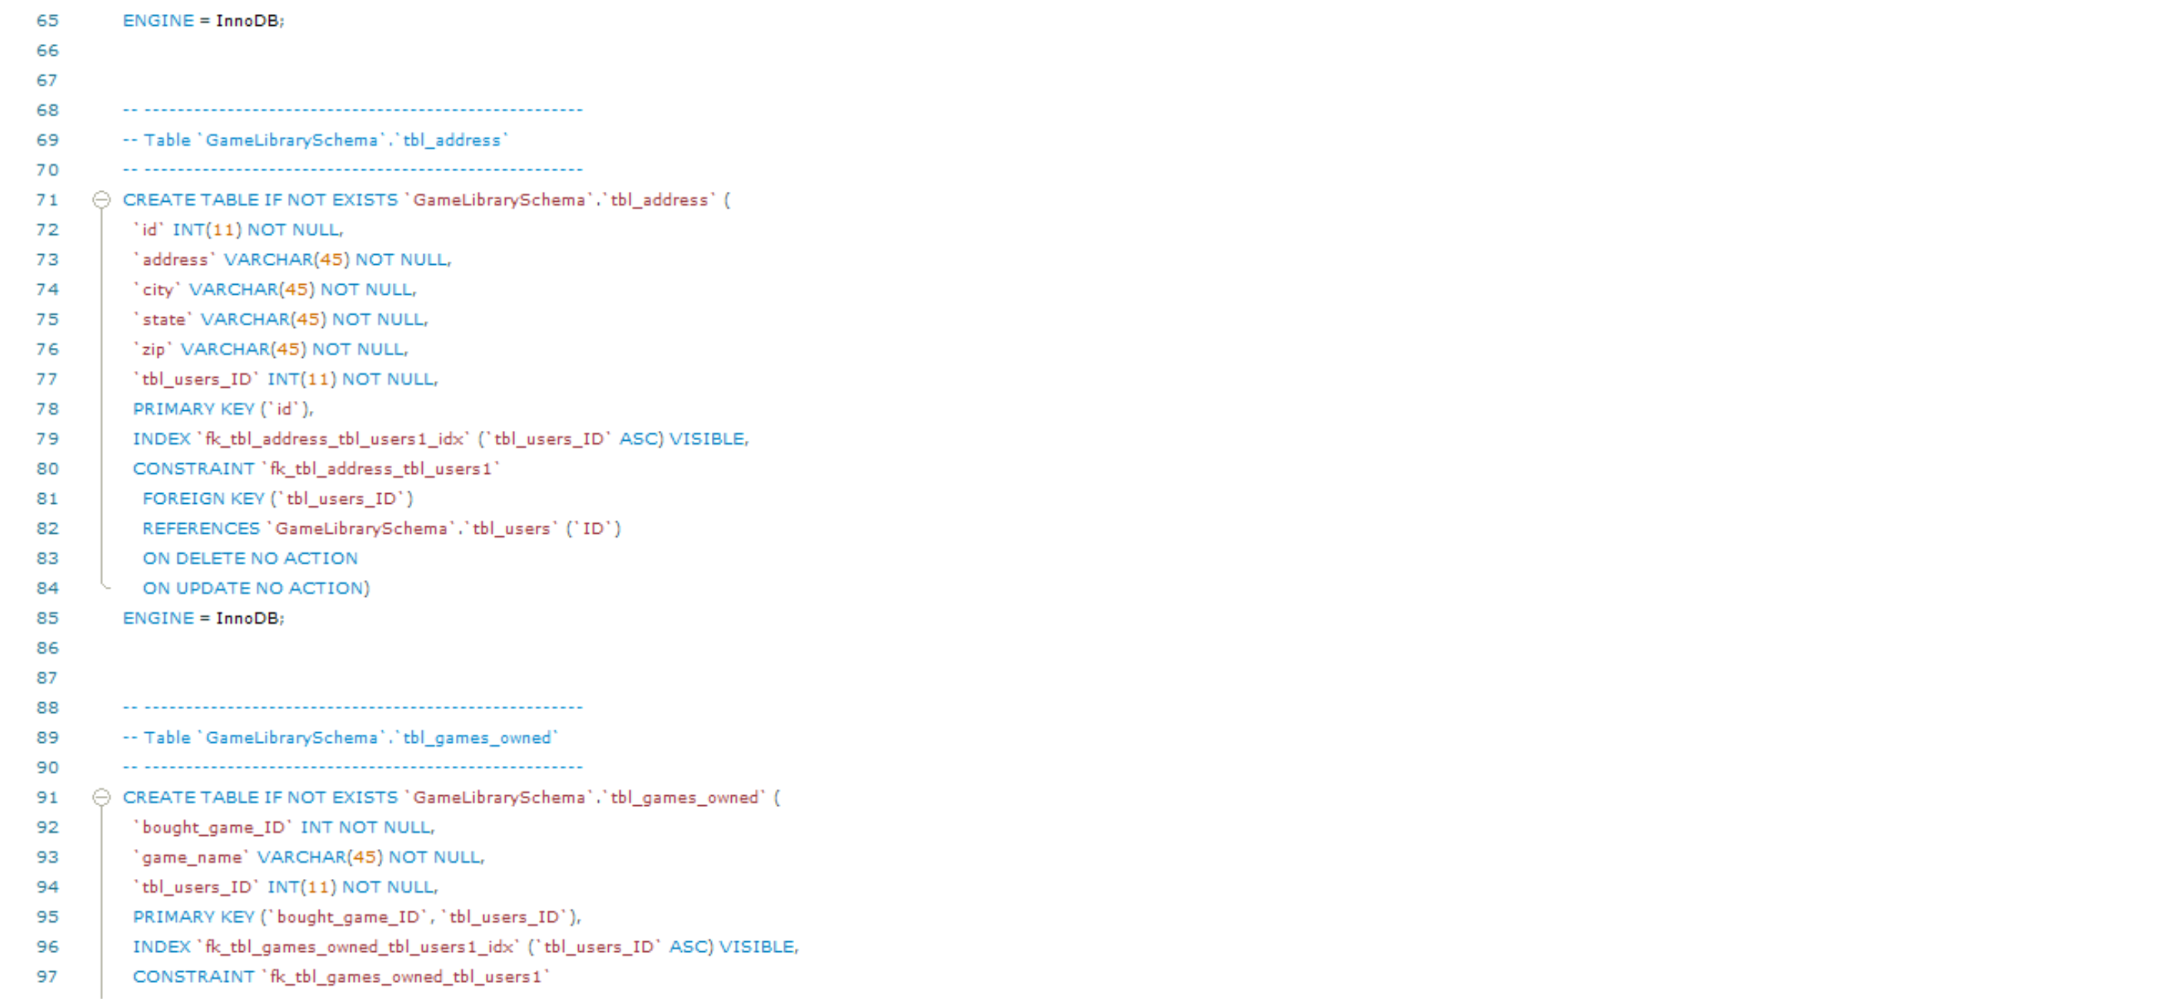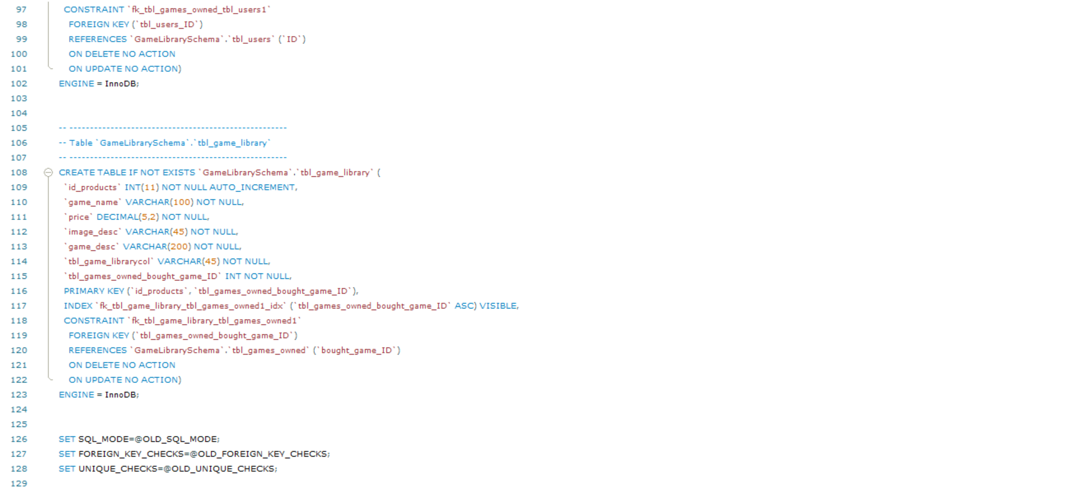

**Sitemap Diagram:**

**User Interface Diagrams:**

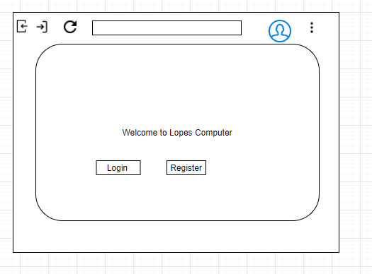

Here is the Home page, registration page, login page and the product catalog page.

**Class Diagrams:**

**Service API Design:**

*We have not gone over the API Design for the Milestone yet.*

**Security Design:**

*The two roles that will be implemented is the consumer role and the administrator role who has the power to edit the e-commerce website. Before you gain access to your product library you need to sign into the Windows application with your account details (username/password) you created. Once your account has been verified by your email you will be able to access your account. When you sign into the Windows app you have the option to “remember me” so you do not have to put your account details in every time.*

**Other Documentation:**

*We do not have any additional documentation or images to add on to the diagrams above.*